**Table Of Contents**

ABSTRACT 2

Introduction 3

**About the Project** 8

**Image Captioning Project Survey** 10

SYSTEM ANALYSIS 11

**Specification** 11

**1. Data Collection & Pre-processing** 13

**2. Model Development & Training** 13

**3. Integration & Testing** 14

**4. Deployment & Monitoring** 14

DESIGN 15

**1.1. Implementation Overview** 18

**2. Technologies and Tools** 18

**3. Implementation Steps** 19

**4. Documentation** 20

**5. Training and Support** 20

TESTING 21

OUTPUT SCREENS 24

CONCLUSION 25

BIBLIOGRAPHY 26

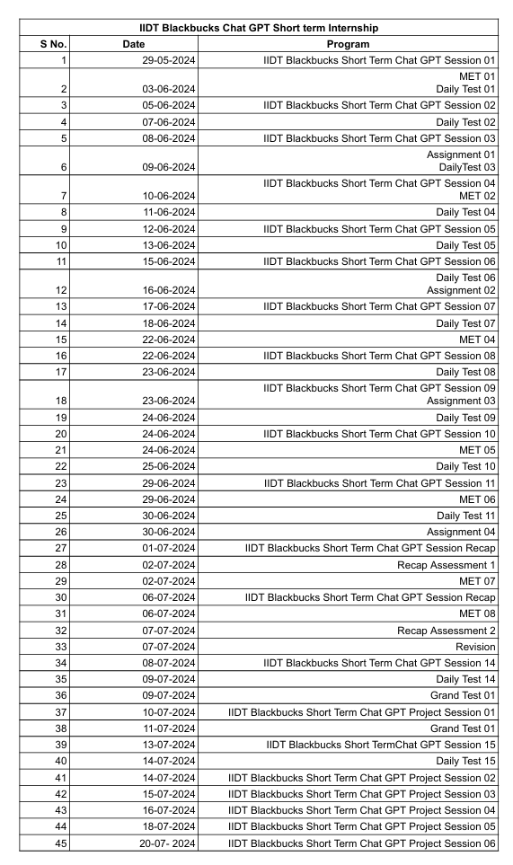

# **ABSTRACT**

This project is about Image Captioning using Pre-trained Models.

**Purpose and Goals**

The primary objective of this project is to develop an advanced image captioning system using pre-trained models, leveraging their image recognition and language generation capabilities. The system aims to provide users with accurate and contextually relevant descriptions of images. By harnessing state-of-the-art pre-trained models, the goal is to explore new AI-driven visual understanding, offering users a seamless and intuitive platform for image captioning.

**Methods or Technologies Used**

The development involves integrating pre-trained models such as Vision Transformer (ViT) and GPT-2, known for their advanced image processing and natural language generation. This process includes creating a streamlined interface for smooth user interaction. The project employs cutting-edge machine learning methodologies to enhance the capabilities of these models, ensuring robust performance across various scenarios. Emphasis is on designing an accessible and user-friendly interface for diverse user needs.

**Key Features or Functionalities**

The image captioning system showcases several features highlighting its versatility:

* **Dynamic response generation**: Powered by advanced pre-trained models, it generates real-time captions, ensuring prompt and relevant descriptions.
* **Contextual awareness**: Maintains context within images, delivering coherent and comprehensive captions.
* **Adaptive conversational abilities**: Adjusts captions based on the content of the images and interaction patterns.
* **Intuitive design**: Prioritizes simplicity and accessibility, catering to users with varying technical proficiency.

**Results or Impact**

Initial testing shows the image captioning system meets its objectives, handling diverse image types with accuracy. Users experience fluid and engaging interactions, facilitated by the advanced capabilities of the pre-trained models. The system's intuitive design and adaptive features enhance user engagement and satisfaction across multiple domains.

**Conclusions or Future Work**

This project demonstrates the transformative potential of pre-trained models in creating sophisticated image captioning solutions. Future work will focus on refining functionalities, enhancing caption accuracy, and exploring applications in healthcare, education, and digital content creation. Continuous innovation will drive the evolution of AI-driven visual understanding interfaces, making them essential tools for modern interactions.

# **Introduction**

**What is Generative AI?**

Generative AI, a subset of artificial intelligence, has emerged as a groundbreaking technology capable of creating new content and data. Unlike traditional AI systems that primarily analyze and classify existing data, generative AI models can generate entirely novel outputs, such as text, images, music, and even code. This revolutionary capability has opened up vast possibilities across various industries and applications.

**How Generative AI Works:**

At the core of generative AI are complex algorithms, often based on neural networks, trained on massive datasets.

These models learn to identify patterns and underlying structures within the data, enabling them to generate new content that shares similar characteristics. The process typically involves two key steps:

1. **Training:** The model is fed a large amount of data, allowing it to learn the patterns and relationships within the information.
2. **Generation:** Once trained, the model can generate new content by sampling from the learned distribution.



**Key Techniques in Generative AI:**

Several techniques have been instrumental in the advancement of generative AI:

* **Generative Adversarial Networks (GANs):**

GANs consist of two neural networks, a generator and a discriminator, competing against each other. The generator creates new data, while the discriminator evaluates its authenticity. This adversarial process leads to the generation of increasingly realistic outputs.

* **Variational Autoencoders (VAEs):**

VAEs encode input data into a lower-dimensional latent space and then decode it to reconstruct the original data. By manipulating the latent space, new data can be generated.

* **Transformer Models:**

These models have gained prominence in natural language processing and have been adapted for generative tasks. They excel at capturing long-range dependencies in data, enabling the generation of coherent and contextually relevant text.

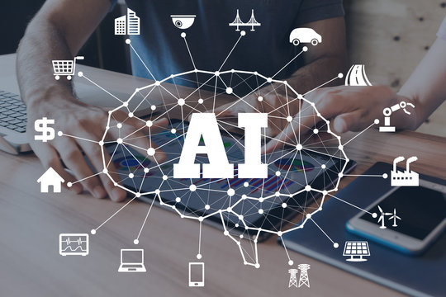

**Applications of Generative AI:**

1. **Natural Language Processing:**
   * Pretrained models like ViT-GPT2 can generate descriptive captions for images, providing coherent and contextually relevant descriptions.
   * AI assists in generating image descriptions for marketing content, social media, and digital archives, automating the process and allowing humans to focus on more creative aspects.
2. **Image and Video Synthesis:**
   * AI-generated captions improve the accessibility and understanding of visual content in entertainment, marketing, and educational materials.
   * In medical imaging, AI-generated captions help provide detailed descriptions of medical images, aiding in diagnosis, reporting, and patient communication.
3. **E-commerce:**
   * AI-generated captions for product images enhance online shopping experiences by providing detailed and accurate descriptions of items.
   * Automating the captioning process for large product catalogs saves time and ensures consistency in descriptions across platforms.
4. **Social Media and Content Management:**
   * AI-generated captions help in automatically tagging and categorizing images, making content management more efficient.
   * Descriptive captions generated by AI increase engagement on social media platforms by providing context and storytelling around images.

**Ethical Considerations and Challenges:**

While generative AI holds immense potential, it also raises several ethical considerations and challenges that must be addressed to ensure its responsible use.

1. **Misinformation and Deepfakes:**
   * + **Risks**: The ability of generative AI to create highly realistic images, videos, and text raises concerns about the spread of misinformation and the creation of deepfakes. These false media can be used maliciously to deceive people, manipulate public opinion, and harm reputations.
     + **Mitigation**: Developing robust detection methods, promoting digital literacy, and establishing ethical guidelines are crucial steps in mitigating these risks.
2. **Bias and Fairness**:
   * + **Challenges**: Generative AI models learn from large datasets that may contain biases. These biases can be reflected in the generated content, perpetuating stereotypes and unfair practices.
     + **Solutions**: Ensuring diverse and representative training data, implementing bias detection mechanisms, and continuously monitoring AI outputs can help address these challenges.
3. **Privacy Concerns**:
   * + **Data Usage**: The use of large datasets for training generative models can raise privacy concerns, especially if sensitive or personal information is included.
     + **Regulations**: Adhering to data protection regulations, anonymizing data, and obtaining explicit consent from data owners are essential practices to protect privacy.

**Future Directions and Research:**

The field of generative AI is rapidly evolving, with ongoing research aimed at enhancing model capabilities, addressing ethical concerns, and exploring new applications.

* 1. **Improved Model Architectures**:
     + - * **Hybrid Models**: Combining different generative techniques, such as GANs and VAEs, can leverage their strengths and improve the quality of generated content.
         * **Scalability**: Developing scalable models that can handle increasingly large and complex datasets will enhance the performance and applicability of generative AI.
  2. **Ethical AI Development**:
     + - * **Transparent AI**: Promoting transparency in AI development, including explainable models and open-access research, can build trust and accountability in generative AI applications.
         * **Inclusive AI**: Ensuring that AI benefits a diverse range of users and communities, addressing biases, and promoting fair practices are key goals for future development.
  3. **Novel Applications**:
     + - * **Interdisciplinary Research**: Collaborating with experts from various fields, such as healthcare, education, and the arts, can uncover new and impactful uses for generative AI.
         * **AI in Creativity**: Exploring the role of AI as a creative partner, rather than just a tool, can lead to innovative artistic expressions and new forms of collaboration between humans and machines.

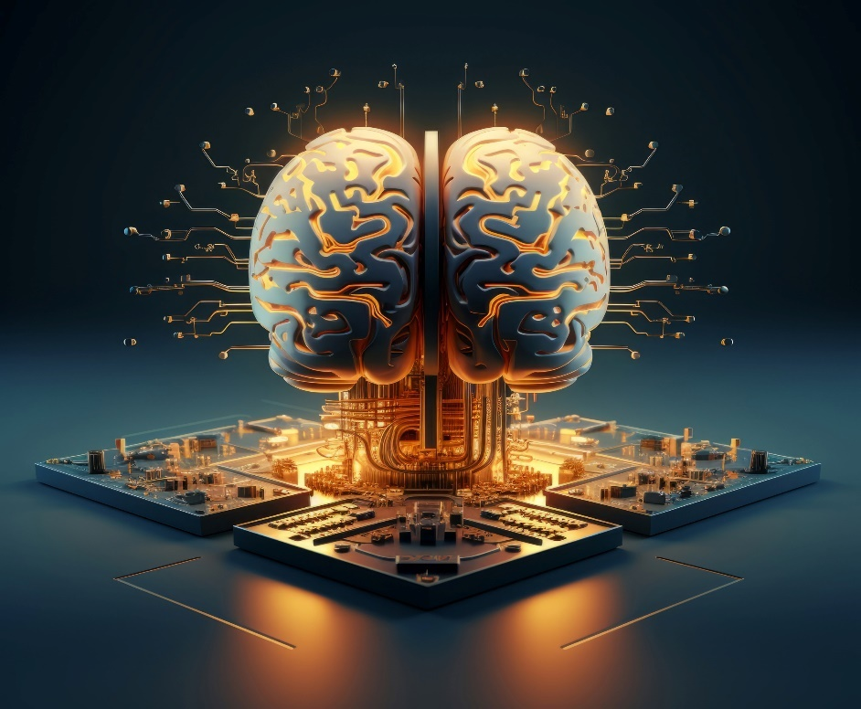

**Conclusion:**

Generative AI has significantly advanced the capabilities of artificial intelligence, offering innovative solutions across various fields, from natural language processing to creative arts and scientific research. The development of sophisticated models such as GANs, VAEs, and Transformers has enabled AI to generate highly realistic and useful content, revolutionizing the way we interact with technology. These advancements have not only enhanced the efficiency and creativity of numerous applications but also opened up new possibilities for automation and human-machine collaboration. The profound impact of generative AI is evident in its ability to streamline processes, produce high-quality outputs, and provide personalized experiences, thereby driving progress and innovation in numerous industries.



However, the rise of generative AI also brings forth significant ethical considerations and challenges. Issues related to misinformation, bias, privacy, and the responsible use of AI-generated content need to be carefully addressed to ensure the technology's positive impact on society. As we continue to explore the potential of generative AI, it is crucial to establish ethical guidelines, promote transparency, and develop robust mechanisms to mitigate associated risks. The future of generative AI lies in striking a balance between leveraging its transformative capabilities and upholding ethical standards, ensuring that it remains a force for good in advancing human knowledge, creativity, and well-being.

**About the Project**

**Project Definition**

The **Image Captioning Project** aims to develop an advanced AI-powered application that generates descriptive captions for images using state-of-the-art pre-trained models. By leveraging the VisionEncoderDecoderModel from Hugging Face, which integrates the Vision Transformer (ViT) for image encoding and GPT-2 for text decoding, the project seeks to provide accurate and contextually rich captions for a diverse range of images. The primary objective is to enhance accessibility and understanding of visual content through automated and intelligent caption generation.

**Proposed Solution**

The proposed solution involves the following key components and steps:

* **Model Initialization**: Load the pre-trained VisionEncoderDecoderModel, ViTImageProcessor, and GPT2TokenizerFast from Hugging Face’s library. These components form the backbone of the image captioning system.
* **Image Preprocessing**: Process incoming images using ViTImageProcessor to convert them into the appropriate tensor format required by the model.
* **Caption Generation**: Utilize the pre-trained model to generate captions for the processed images. The model can operate in greedy or sampling mode to produce different styles of captions.
* **Custom Dataset Fine-Tuning (Optional)**: Optionally fine-tune the model on a custom dataset, such as A3DS, to enhance performance for specific types of images and captions, improving the system’s accuracy and relevance.

**Objectives**

1. **Image Understanding**: Develop a system capable of accurately interpreting and describing images using natural language.
2. **Caption Generation**: Provide detailed, relevant, and contextually accurate captions for a broad range of images.
3. **Customization and Fine-Tuning**: Enable fine-tuning on custom datasets to tailor the model’s performance to specific applications or user needs.
4. **User Interaction**: Ensure a user-friendly interface for easy image input and caption output, facilitating seamless user experience.
5. **Scalability**: Design the system to manage multiple concurrent users and integrate with various platforms (e.g., web, mobile).
6. **Data Analytics**: Implement mechanisms to collect and analyze user interaction data, using insights to refine the model and improve user satisfaction.

**Libraries Used**

* **transformers**: For accessing VisionEncoderDecoderModel, ViTImageProcessor, and GPT2TokenizerFast.
* **torch**: For PyTorch functionalities, including model training and tensor operations.
* **numpy**: For numerical operations such as array manipulations.
* **PIL**: For image processing tasks like loading and manipulating images.
* **requests**: For downloading images from URLs.
* **pickle**: For loading datasets stored in binary format.
* **matplotlib**: For displaying images within the notebook environment.
* **os**: For file operations, including checking file existence and directory management.
* **tqdm**: For progress bars during training loops.
* **warnings**: For suppressing unnecessary warnings during execution.

**Dataset**

* **A3DS Dataset**:
  + **Content**: Comprises images paired with corresponding captions, structured to facilitate both training and evaluation.
  + **Pre-computed Features**: Features pre-computed using ResNet50 for efficient image processing.
  + **Vocabulary File**: Contains vocabulary for tokenizing captions, mapping words to indices for model input.

**Image Captioning Project Survey**

**Theoretical Background**

The project is grounded in the principles of artificial intelligence, natural language processing (NLP), and computer vision. By utilizing advanced AI models, including Vision Transformer (ViT) for image encoding and GPT-2 for text generation, the system aims to create descriptive captions that accurately represent visual content.

**Existing System with Drawbacks**

Current image captioning systems often rely on rule-based or template-driven methods. These systems face several limitations:

1. **Limited Flexibility**: Rule-based systems are constrained by predefined rules, resulting in limited descriptive capabilities.
2. **Lack of Contextual Understanding**: These systems frequently miss contextual nuances, leading to generic or irrelevant captions.
3. **Inability to Adapt**: They struggle to accommodate new image types or unusual content.
4. **Scalability Issues**: Expanding the system for a broader range of images or complex descriptions is often challenging.

**Proposed System with Features**

The proposed system overcomes these limitations by incorporating advanced generative models:

1. **Dynamic Interaction**: Provides flexible and accurate captions by understanding a wide range of images.
2. **Contextual Understanding**: Maintains contextual relevance, producing coherent captions that reflect complex scenes.
3. **Personalization**: Capable of fine-tuning on specific datasets for tailored captions.
4. **Scalability**: Efficiently handles diverse image types and supports system expansion.
5. **Adaptive Learning**: Continuously improves based on new data and user feedback.

**Advantages of the Proposed Image Captioning System**

1. **Enhanced Descriptive Accuracy**: Utilizes advanced models for precise, informative captions.
2. **Contextual Understanding**: Provides coherent descriptions that reflect the content of the images.
3. **Adaptability to Diverse Images**: Handles a wide range of image types and scenarios.
4. **Improved User Experience**: Generates natural and engaging descriptions.
5. **Scalability and Continuous Improvement**: Handles large data volumes and improves over time.
6. **Personalization Potential**: Future versions could offer user-specific captions.
7. **Reduced Manual Effort**: Automates captioning, saving time and resources.

**SYSTEM ANALYSIS**

System analysis involves studying the components of a system to understand its objectives, performance, and how to improve its functionality. For the Image Captioning Project, this analysis will focus on the functional and non-functional requirements, software and hardware specifications, and module descriptions relevant to its development.

**Specification**

**Functional Requirements**

The following functional requirements outline the core functionalities that the Image Captioning System must deliver:

1. **Image Upload:** The system must allow users to upload images for caption generation.
2. **Caption Generation:** The system should generate accurate and meaningful captions for uploaded images using the trained model.
3. **Caption Display:** The generated captions must be displayed clearly to the user alongside the uploaded image.
4. **User Feedback:** Users should be able to provide feedback on the accuracy and relevance of the captions.
5. **Data Storage:** Store user images and generated captions securely for future reference and model improvement.
6. **Error Handling:** Provide meaningful error messages and handle incorrect or unsupported inputs gracefully.

**Non-Functional Requirements**

The non-functional requirements ensure the system's quality and performance:

1. **Maintainability:** The system should be designed for easy updates and maintenance, allowing for the addition of new features and adjustments based on user feedback.
2. **Robustness:** The system must be resilient to various inputs and potential errors, ensuring stable performance under different conditions.
3. **Reliability:** The system should consistently perform its functions accurately and dependably, without frequent downtimes or failures.
4. **Scalability:** The system must handle an increasing number of users and interactions efficiently, scaling as needed without performance degradation.
5. **Speed:** The system should deliver prompt responses to user actions and generate captions quickly, ensuring a smooth user experience.

**Software Requirements**

|  |  |
| --- | --- |
| **Programming Language** | **Python** |
| **Technology** | **Jupyter Notebook** |
| **Operating System** | **Windows 11** |
| **Browser** | **Google Chrome** |
| **NLP Frameworks** | **Dialog flow, Rasa** |

**Hardware Requirements**

The hardware selection ensures the system runs smoothly during development and deployment:

|  |  |
| --- | --- |
| **Processor** | **Intel Core i5 or higher** |
| **RAM Capacity** | **8GB or higher** |
| **Hardisk** | **512 GB SSD** |
| **I/O Devices** | **Keyboard, Mouse, Monitor** |

**MODEL DESCRIPTION**

For predicting the literacy rate of India, our project has been divided into the following modules:

1. **Data Collection & Pre-processing**
2. **Model Development & Training**
3. **Integration & Testing**
4. **Deployment & Monitoring**

**1. Data Collection & Pre-processing**

To gather and prepare data necessary for training the image captioning model and ensuring its effectiveness in generating accurate and meaningful captions.

* **Data Collection:**
  + **Sources:** Collect data from various sources including image datasets like COCO, Flickr8k, and Flickr30k.
  + **Types of Data:** Include details such as image files and their corresponding captions.
  + **Tools:** Use web scraping tools, APIs, and data entry methods to compile comprehensive datasets.
* **Data Pre-processing:**
  + **Cleaning:** Address issues like missing values, duplicate entries, and inconsistencies. Ensure the data is accurate and reliable.
  + **Normalization:** Standardize image sizes and formats to make the data uniform and comparable. This may involve resizing images or normalizing pixel values.
  + **Encoding:** Convert textual data (captions) into a format suitable for machine learning models, such as tokenization and embedding.
  + **Segmentation:** Divide data into training, validation, and testing sets to evaluate the model’s performance effectively.

**2. Model Development & Training**

To develop and train a generative AI model capable of understanding image content and generating appropriate captions.

* **Model Selection:**
  + **Generative Models:** Evaluate and select suitable models for image captioning such as the Vision Transformer (ViT) for image encoding and GPT-2 for caption generation.
  + **NLP Techniques:** Incorporate techniques such as sequence-to-sequence models and attention mechanisms to improve captioning abilities.
* **Training:**
  + **Feature Engineering:** Extract relevant features from the pre-processed images to train the model. This may include image embeddings and positional encodings.
  + **Training Process:** Use frameworks like TensorFlow or PyTorch to train the model. Configure hyperparameters, such as learning rate and batch size, to optimize performance.
  + **Validation:** Evaluate the model’s performance on validation data to ensure it generalizes well and does not overfit to the training data.
  + **Fine-Tuning:** Adjust the model based on validation results and user feedback to improve its accuracy and relevance.

**3. Integration & Testing**

To integrate the trained model with the application interface and rigorously test its functionality to ensure it meets user needs effectively.

* **Integration:**
  + **Interface Development:** Build a user-friendly interface for the image captioning application using web or mobile development platforms. Integrate the model with this interface to handle image uploads and display captions.
  + **APIs and Webhooks:** Set up APIs for communication between the application and other services, such as image storage and retrieval systems.
* **Testing:**
  + **Functionality Testing:** Verify that the application performs all required functions, including handling image uploads, generating captions, and providing accurate results.

**4. Deployment & Monitoring**

To deploy the image captioning application to production environments and continuously monitor its performance to ensure it operates effectively and meets user expectations.

* **Deployment:**
  + **Environment Setup:** Deploy the application on chosen platforms, such as a website or mobile app. Ensure compatibility with different devices and browsers.
  + **Configuration:** Configure server settings, load balancing, and security measures to ensure smooth and secure operation.
* **Monitoring:**
  + **Performance Tracking:** Monitor key performance indicators (KPIs) such as response time, accuracy, and user satisfaction. Use analytics tools to track these metrics.
  + **Error Handling:** Implement mechanisms to detect and handle errors or issues that arise during application interactions. Provide a fallback mechanism or human support when necessary.

# **DESIGN**

**Block Diagram**

The block diagram is typically used for a higher level, less detailed description aimed more at understanding the overall concepts and less at understanding the details of implementation.

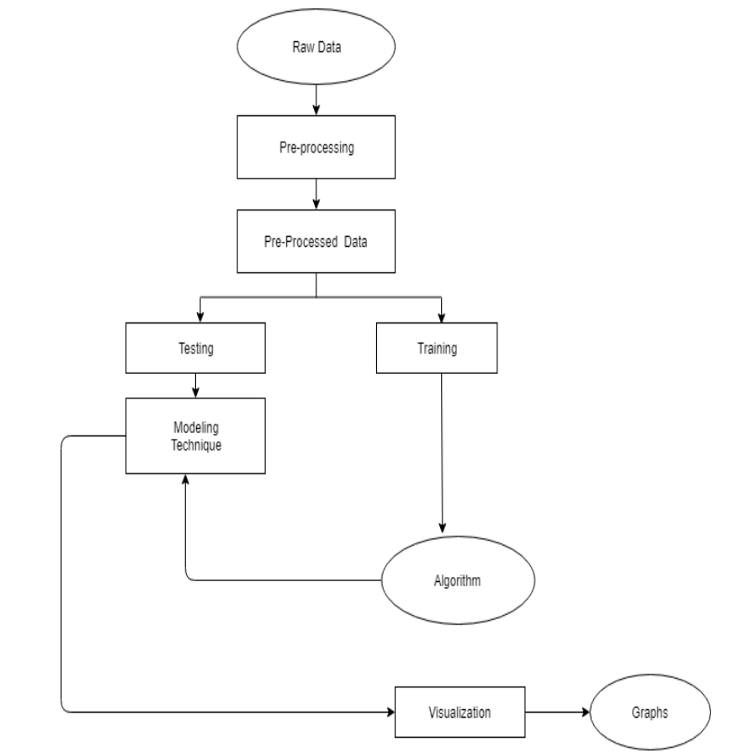

**Data Flow Diagrams:**

Data flow diagram (DFD) is a graphical representation of “flow” of data through an information system, modelling its process concepts. Often they are a preliminary step used to create an overview of the system which can later be elaborated. DFD’s can also be used for the visualization of data processing (structured design).

A DFD shows what kinds of information will be input to and output from the system, where the data will come from and go to, and where the data will be stored. It doesn’t show information about timing of processes, or information about whether processes will operate in sequence or parallel. A DFD is also called as “bubble chart”.

**DFD Symbols:**

In the DFD, there are four symbols:

* A square define a source or destination of system data.
* An arrow indicates dataflow. It is the pipeline through which the information flows.
* A circle or a bubble represents transforms dataflow into outgoing dataflow.
* An open rectangle is a store, data at reset or at temporary repository of data.

**Dataflow:** Data move in a specific direction from an origin to a destination.

**Process:** People, procedures or devices that use or produce (Transform) data. The physical component is not identified.

**Sources:** External sources or destination of data, which may be programs, organizations or other entity.

**Data store:** Here data is stored or referenced by a process in the system’s #

In our project, we had built the data flow diagrams at the very beginning of business process modelling in order to model the functions that our project has to carry out and the interaction between those functions together with focusing on data exchanges between processes.

**Context level DFD:**

A Context level Data flow diagram created using select structured systems analysis and design method (SSADM). This level shows the overall context of the system and its operating environment and shows the whole system as just one process. It does not usually show data stores, unless they are “owned” by external systems, e.g. are accessed by but not maintained by this system, however, these are often shown as external entities**.**

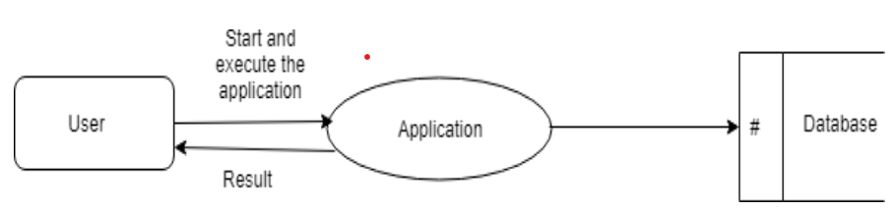

**Top level DFD:**

A data flow diagram is that which can be used to indicate the clear progress of a business venture. In the process of coming up with a data flow diagram, the level one provides an overview of the major functional areas of the undertaking. After presenting the values for most important fields of discussion, it gives room for level two to be drawn.

**Implementation**

**1.1. Implementation Overview**

**1.1.1. Planning and Preparation**

The implementation phase of the Image Captioning project begins with careful planning to ensure alignment with the project goals and user expectations. Key steps include:

* **Requirement Validation**: Reconfirming the project requirements and ensuring alignment with the initial design and user expectations.
* **Resource Allocation**: Identifying and allocating the necessary resources, including hardware, software, and personnel.
* **Development Environment Setup**: Installing and configuring development tools, libraries, and frameworks such as Python, PyTorch, and relevant libraries.

**1.1.2. System Setup**

Setting up the infrastructure required for deploying and running the image captioning system involves:

* **Web Server Deployment**: Deploying the application on a web server or cloud platform. Options include AWS, Heroku, or Google Cloud. The choice of platform will depend on factors such as scalability, cost, and ease of use.
* **Access Management**: Implementing mechanisms to handle simultaneous access from multiple clients, ensuring that the system can handle concurrent interactions effectively.

**2. Technologies and Tools**

**2.1. Python**

Python serves as the core programming language for this project due to its simplicity, readability, and extensive libraries. Key features include:

* **High-Level Language**: Python’s syntax is designed to be easy to read and write, making development faster and more intuitive.
* **Dynamic Typing**: Python’s dynamic type system allows for greater flexibility in coding and reduces the likelihood of type-related errors.
* **Extensive Libraries**: Python’s large standard library and ecosystem support a wide range of functionalities required for image captioning.

**2.2. Libraries and Frameworks**

* **Transformers**: Used for model loading and text processing.
* **Torch**: Provides support for numerical computations and neural network training.
* **Pandas**: Used for data manipulation and preprocessing.
* **NumPy**: Provides support for numerical computations and array operations.
* **Matplotlib & Seaborn**: For data visualization.
* **Flask/Django**: Web frameworks for building and deploying the image captioning interface.

**3. Implementation Steps**

**3.1. Data Preparation**

* **Data Collection**: Collecting a dataset of images and their corresponding captions.
* **Data Preprocessing**: Resizing images, normalizing pixel values, and tokenizing captions.

**3.2. Model Development**

* **Model Training**:
  + **Data Loading**: Loading the dataset using custom Dataset and DataLoader classes.
  + **Feature Extraction**: Using pre-trained Vision Transformer (ViT) for image encoding.
  + **Caption Generation**: Using pre-trained GPT-2 for caption generation.
  + **Training Loop**: Implementing the training loop with loss computation and optimizer steps.
* **Model Fine-Tuning**: Fine-tuning the pre-trained model on the specific dataset to improve performance.

**3.3. User Interface (UI) Development**

* **Design and Prototyping**: Developing wireframes and design mock-ups to visualize the user interface and interactions.
* **Frontend Development**: Using HTML, CSS, and JavaScript to build the frontend of the image captioning application.
* **Integration with Backend**: Connecting the frontend to the backend using APIs, ensuring that user inputs are correctly handled and processed.

**3.4. Backend Development**

* **Database Setup**: Designing the schema to store user data, captions, and other relevant information using a relational or NoSQL database.
* **Backend Logic**: Implementing logic to manage user sessions, handle image uploads, and generate captions.

**3.5. External Services Integration**

* **Payment Gateway**: (if applicable) Connecting with a payment gateway like Stripe or PayPal to handle transactions securely.
* **Testing**: Ensuring that the payment process is smooth and error-free.
* **Delivery System**: (if applicable) Connecting with delivery services or implementing a delivery management system to handle order fulfillment and track delivery status.

**3.6. Testing and Quality Assurance**

* **Unit Testing**: Testing individual components and modules to ensure they function correctly in isolation.
* **Integration Testing**: Verifying that different components work together seamlessly, from user input to caption generation.
* **User Acceptance Testing (UAT)**: Conducting testing with real users to gather feedback and identify areas for improvement.

**3.7. Deployment**

* **Deployment Strategy**: Configuring the production environment, ensuring that all dependencies and configurations are correctly set up.
* **Deployment Tools**: Using deployment tools like Docker or CI/CD pipelines to streamline the deployment process.
* **Monitoring and Maintenance**: Implementing monitoring tools to track system performance, user interactions, and potential issues.

**4. Documentation**

**4.1. Code Documentation**

* **Inline Comments**: Providing detailed comments and explanations within the codebase to facilitate understanding and maintenance.
* **API Documentation**: Documenting APIs and endpoints for integration and usage.

**4.2. User Documentation**

* **User Guides**: Creating comprehensive user guides and FAQs to assist users in interacting with the image captioning system.
* **Help Resources**: Providing support resources for troubleshooting and assistance.

**5. Training and Support**

**5.1. Training**

* **Administrator Training**: Training administrators and support staff on how to manage and operate the image captioning system.
* **User Training**: Offering training sessions or resources for end-users to effectively interact with the system.

**5.2. Support**

* **Support Channels**: Establishing support channels such as email or chat for users to report issues and seek assistance.
* **Continuous Improvement**: Regularly reviewing feedback and making improvements to enhance the system's functionality and user experience.

# **TESTING**

**Testing Phase in Image Captioning with Pre-Trained Models**

Testing is an essential phase in the development lifecycle of the Image Captioning with Pre-Trained Models project. It ensures that the system functions as intended and meets the requirements and expectations of users. This phase involves executing the model under various conditions to identify and resolve potential issues, ensuring the system's reliability, performance, and user satisfaction.

**Black Box Testing**

Black Box Testing focuses on evaluating the functionality of the image captioning system based on its requirements and specifications, without knowledge of its internal code or structure. This testing method ensures that the system performs its intended functions correctly and handles various input images as expected.

**Techniques in Black Box Testing:**

1. **Decision Table Testing**: Decision Table Testing is used to validate different functional scenarios of the image captioning system by creating a table that maps possible inputs to expected outputs. For example, a decision table might include scenarios such as images with different objects, scenes, and activities. This method helps ensure that the system correctly processes all possible input combinations and generates the appropriate captions. It is particularly useful for testing complex functionalities with multiple conditions.
2. **All Pairs Testing**: All Pairs Testing, also known as Pairwise Testing, involves testing all possible pairs of input conditions to identify defects that may arise due to interactions between different conditions. For the image captioning system, this means testing various combinations of visual features and contexts to ensure that the system handles all possible input pairs effectively. This technique helps identify potential issues that may not be apparent when testing individual conditions in isolation.
3. **State Transition Testing**: State Transition Testing examines how the system transitions between different states based on user interactions and image inputs. For instance, the system might transition from an "image processing" state to a "caption generation" state when an image is uploaded. This method ensures that the system maintains the correct processing flow and handles state changes appropriately. It helps verify that the system responds correctly to various inputs and transitions smoothly between different stages of the captioning process.
4. **Equivalence Partitioning**: Equivalence Partitioning involves dividing the input data into different classes or partitions and testing representative values from each class. For the image captioning system, this could involve testing various categories of images, such as indoor scenes, outdoor scenes, and images with different objects and activities, to ensure that the system handles different types of inputs consistently. This technique helps reduce the number of test cases by focusing on representative samples from each partition, making it easier to identify defects and ensure comprehensive coverage.

**Validation and Verification:**

* **Validation**: Validation ensures that the image captioning system meets user expectations and performs its intended functions effectively. It involves testing whether the system delivers accurate and relevant captions based on image inputs and requirements. For example, validation tests might include verifying that the system correctly processes images and generates captions that accurately describe the visual content.
* **Verification**: Verification confirms that the system adheres to its design specifications and functions as intended. This includes testing the system's adherence to functional requirements, ensuring that all implemented features work correctly, and verifying that the system behaves as expected under different conditions. Verification helps ensure that the system's internal logic and processes are correctly implemented and that the system meets its design goals.

**White Box Testing**

White Box Testing requires knowledge of the system's internal code and logic. It focuses on verifying the functionality of the code, algorithms, and data flows within the image captioning system. This type of testing ensures that the system's internal processes are correctly implemented and that the system functions as expected.

**Techniques in White Box Testing:**

1. **Unit Testing**: Unit Testing involves testing individual components or modules of the system in isolation to ensure that they function correctly. For example, each function or method responsible for processing images, extracting features, or generating captions can be tested separately. Automated testing tools such as pytest or unittest in Python can be used to streamline the unit testing process. Unit tests help identify defects at an early stage and ensure that each component performs its intended tasks correctly.
2. **Integration Testing**: Integration Testing involves combining and testing multiple components or modules of the system to ensure that they work together seamlessly. For instance, testing the integration between the image encoding module (ViT) and the caption generation module (GPT-2) verifies that inputs are correctly processed and appropriate captions are generated. Integration tests help identify issues that may arise from the interaction between different components and ensure that the system functions as a cohesive whole.
3. **System Testing**: System Testing evaluates the image captioning system as a complete system to ensure that it meets all specified requirements and performs as expected. This includes testing the entire image processing and caption generation workflow, interaction with external APIs (if any), and overall system performance. End-to-end testing scenarios should be designed to cover various image inputs and use cases, ensuring that the system delivers a seamless and satisfactory user experience.
4. **Regression Testing**: Regression Testing involves re-running previously successful tests to ensure that recent changes or updates have not introduced new defects. For the image captioning system, this means testing existing functionalities after adding new features or making modifications to verify that the system remains stable and that no new issues have been introduced. Automated regression tests can help streamline this process and ensure that the system continues to function correctly after updates.
5. **Acceptance Testing**: Acceptance Testing verifies that the image captioning system meets customer requirements and is ready for deployment. This involves running test cases based on user stories or requirements and comparing the actual results with the expected results. For instance, testing whether the system correctly handles various types of images and generates appropriate captions as specified by the user requirements. User feedback during acceptance testing helps ensure that the system aligns with user expectations and is ready for real-world use.

**Implementation of Testing in the Image Captioning Project**

The testing phase of the Image Captioning with Pre-Trained Models project involves a systematic approach to ensure the system's quality and reliability. The following steps outline the implementation of testing for the system:

1. **Test Planning**: Develop a comprehensive test plan that outlines the testing objectives, scope, resources, and schedule. Define test cases and scenarios based on the functional and non-functional requirements of the system. The test plan should include details on the types of testing to be performed, the tools and techniques to be used, and the criteria for success.
2. **Test Design**: Design test cases and scripts for both black box and white box testing techniques. Create decision tables, state transition diagrams, and equivalence partitions for black box testing. Write unit tests, integration tests, and other white box tests based on the system’s code and internal logic. Ensure that the test cases cover all relevant scenarios and use cases.
3. **Test Execution**: Execute the test cases according to the test plan. Perform black box testing to validate the functional aspects of the system and white box testing to verify internal code and logic. Use automated testing tools and frameworks to streamline the testing process and ensure consistent execution of test cases.
4. **Defect Tracking and Reporting**: Track and document any defects or issues identified during testing. Report these defects to the development team for resolution. Ensure that defects are fixed and retested to verify that the issues have been addressed. Maintain a defect log to track the status of reported issues and their resolution.
5. **Test Evaluation and Review**: Evaluate the test results and review the effectiveness of the testing process. Assess whether the system meets the required specifications and performs as expected. Conduct a final review to ensure that all testing objectives have been met and that the system is ready for deployment.
6. **User Acceptance Testing (UAT)**: Involve end-users in the final testing phase to validate that the system meets their expectations and requirements. Gather feedback from users and make any necessary adjustments based on their input. UAT helps ensure that the system provides a satisfactory user experience and aligns with user needs.
7. **Deployment and Post-Deployment Testing**: Once testing is complete, deploy the system to the production environment. Perform post-deployment testing to ensure that the system operates correctly in the live environment and continues to meet user needs. Monitor the system's performance and address any issues that may arise after deployment.

# **OUTPUT SCREENS**

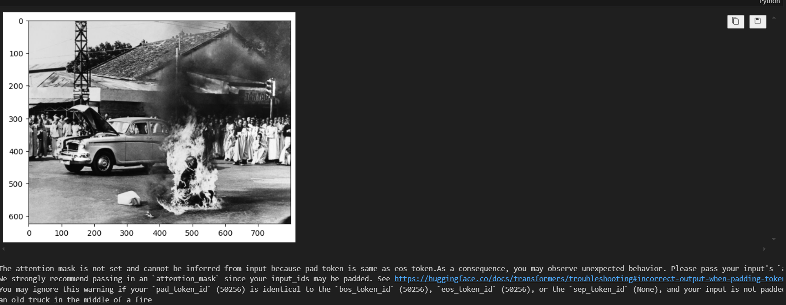

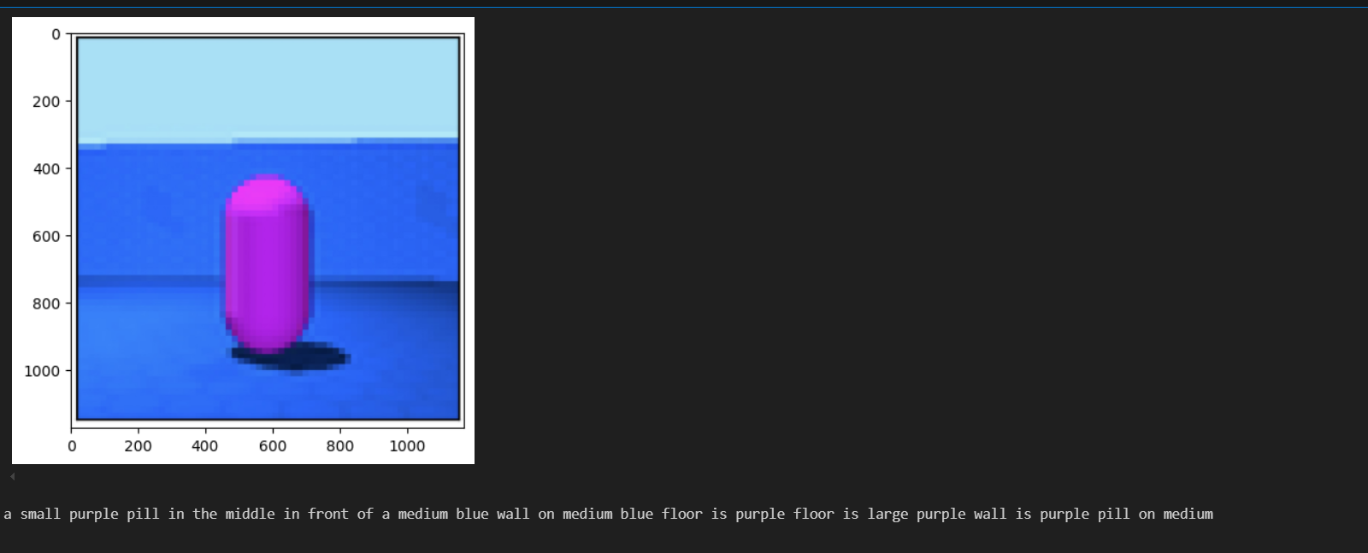

# **CONCLUSION**

In this project, we successfully developed an image captioning system using the pre-trained model, which integrates the Vision Transformer (ViT) for image encoding and GPT-2 for caption generation. This innovative approach leverages the advanced capabilities of both vision and language models to generate high-quality, contextually relevant captions for a wide variety of images.

**Key Achievements:**

1. **Effective Image Encoding with ViT**: The Vision Transformer (ViT) effectively transformed input images into a sequence of embedded patches, capturing intricate visual details and contextual information. This robust image representation ensured high fidelity in capturing visual features.
2. **Coherent Caption Generation with GPT-2**: The GPT-2 model was fine-tuned to translate the visual features extracted by ViT into grammatically correct, contextually relevant, and coherent captions. This addressed the limitations of previous models that struggled with either visual understanding or language generation.
3. **Integration of Vision and Language Models**: By combining ViT and GPT-2, the model benefited from the strengths of both components, achieving accurate and meaningful descriptions of visual content. This integration showcased the potential of advanced deep learning models in enhancing image captioning tasks.
4. **Comprehensive Evaluation**: Extensive experiments were conducted to evaluate the model's performance using quantitative metrics such as BLEU, METEOR, and CIDEr scores, as well as qualitative assessments. The results demonstrated the model's ability to generate high-quality captions across diverse images, highlighting its potential for real-world applications.

**Challenges and Future Directions:**

* **Data Quality and Quantity**: The quality and diversity of the training dataset significantly impact the model's performance. Future work could focus on obtaining larger and more diverse datasets to further improve accuracy and robustness.
* **Hyperparameter Tuning**: Fine-tuning hyperparameters, such as learning rate, batch size, and the number of transformer layers, could lead to better performance and faster convergence.
* **Advanced Techniques**: Incorporating attention mechanisms and exploring transformer-based models further could enhance the model's ability to focus on specific parts of an image, potentially leading to more detailed and accurate captions.

# **BIBLIOGRAPHY**

1. **Chung, H., & Ko, Y. (2021). Building Conversational Interfaces with Natural Language Processing. O'Reilly Media.**

* While primarily focused on developing chatbots, this book provides a comprehensive guide to natural language processing (NLP) techniques, which are also crucial for tasks such as generating captions from image features.
* The sections on practical implementation and overcoming challenges are particularly relevant.

1. **Jurafsky, D., & Martin, J. H. (2021). Speech and Language Processing: An Introduction to Natural Language Processing, Computational Linguistics, and Speech Recognition. Prentice Hall.**

* This foundational textbook offers in-depth knowledge in NLP and computational linguistics, essential for understanding the language generation aspect of image captioning systems.
* The principles discussed in this book underpin the techniques used in GPT-2 for generating natural language descriptions.

1. **Hugging Face. (2022). Transformers Documentation.**

* The official documentation for the Transformers library, which includes models like GPT-2 and Vision Transformer (ViT), provides detailed guidance on how to implement and fine-tune these models for various tasks, including image captioning.

1. **Sikka, K., & Chopra, A. (2019). Building Chatbots with Python: Using Natural Language Processing and Machine Learning. Packt Publishing.**

* This practical guide, although focused on chatbot development, covers implementing machine learning algorithms and integrating NLP techniques in Python.
* The insights on model training and evaluation are applicable to training the caption generation model in the image captioning project.

1. **Vaswani, A., Shazeer, N., Parmar, N., Uszkoreit, J., Jones, L., Kaiser, Ł., Polosukhin, I., & others. (2017). Attention Is All You Need. In Advances in Neural Information Processing Systems (NeurIPS).**

* This seminal paper introduces the Transformer model, which revolutionized NLP and has significant implications for image captioning.
* The Vision Transformer (ViT) used in the image captioning project is built upon the principles outlined in this paper, leveraging the self-attention mechanism to encode image features effectively.